VIETNAM GENERAL CONFEDERATION OF LABOUR

**TON DUC THANG UNIVERSITY**

**FACULTY OF INFORMATION TECHNOLOGY**



**Final Project**

**Web Programming and Applications**

*Advised by*: **NGUYEN NGOC PHIEN**

*Student*: **TRAN HUU DAT – 522H0081**

**PHAM DUY KHANH – 522H0064**

**HOANG LONG VU – 522H0018**

Course  **: 26**

**HO CHI MINH CITY, YEAR 2024**

# ACKNOWLEDGMENTS

We extend our sincere appreciation to Nguyen Ngoc Phien for his expert guidance and steadfast support during the crafting of this report. His extensive knowledge and insights have significantly enhanced our understanding and methodology in the study of Web Programming and Applications. We are profoundly thankful for his dedication, patience, and the considerable time he has devoted to us.

TABLE OF CONTENT

ACKNOWLEDGMENTS 2

I. Assigned tasks of team members 4

1. Assignment of Tasks for Team Members: 4

2. Presentation of the Web Product: 4

II. Overview of the website 4

1.Website Concept 4

2.Website Content 4

III. Main Website Functions 5

1. Registration and Login Functionality 5

a. Account Registration 5

b. Login 6

c. User Management (For Administrators) 6

2. Recipe Post Management Functions 7

a. Overview of Posts: 7

b. Management of Posts 9

c. Recipe Post Search 10

d. Interactions in Recipe Posts 11

e. Adding, Deleting, Editing Categories 12

REFERENCES 13

# 

# ****I. Assigned tasks of team members****

## 1. Assignment of Tasks for Team Members:

* **Khánh**: Responsible for developing the frontend of the user interface, including **HTML, CSS, and JavaScript** programming to create a dynamic and user-friendly website.
* **Vũ**: Takes charge of backend programming using **PHP**, building functions to process data and interact with the database.
* **Đạt**: Tasked with **researching and compiling software data**, drafting detailed and accurate content for the report.

## 2. Presentation of the Web Product:

Khánh and Vũ will jointly present and showcase the web product, ensuring that the information is conveyed clearly and captures the audience's attention.

# ****II. Overview of the website****

## 1.Website Concept

Our website is designed as a miniature social network, where people can freely share and explore unique cooking recipes. It's not just a platform for posting your own recipe articles, but also a community where people can interact through comments, suggestions, and sharing experiences. Each post is not only a cooking recipe but also a story, a secret, and a love for food that the sharer wants to convey.

## 2.Website Content

Our website provides a valuable repository of information about familiar dishes, serving as an indispensable companion for every meal. Here's what you can expect from this website:

* **Diverse dishes:** From quick and easy breakfasts to cozy dinners, from refreshing drinks to sweet desserts, our website will help you explore and prepare a variety of dishes.
* **Detailed instructions:** Each cooking recipe is meticulously and comprehensively guided, making it easy for readers to follow and execute, even for beginners.
* **Easy implementation:** The cooking recipes are designed to cater to everyone, from homemakers to busy individuals, ensuring that everyone can create delicious dishes without spending too much time or effort.

# III. Main Website Functions

## 1. Registration and Login Functionality

### a. Account Registration

Users can create a new account on the website by filling out the registration form with the following information: First Name, Last Name, Username, Email, Password, and uploading a profile picture. The registration interface is designed to ensure intuitive and user-friendly experience.



**Note on uploading images:** When uploading profile pictures or other files, the system only accepts file formats .png and .jpg to ensure compatibility and security.

### b. Login

After registration, users can log in using their username and password to access and utilize the exclusive features of the website. The login interface is optimized to ensure a quick and secure login process.



### c. User Management (For Administrators)

- **Add User:** Administrators can add new user information with predefined roles, including 'author' or 'admin'. The 'Add User' interface is designed to allow administrators to easily perform this task.

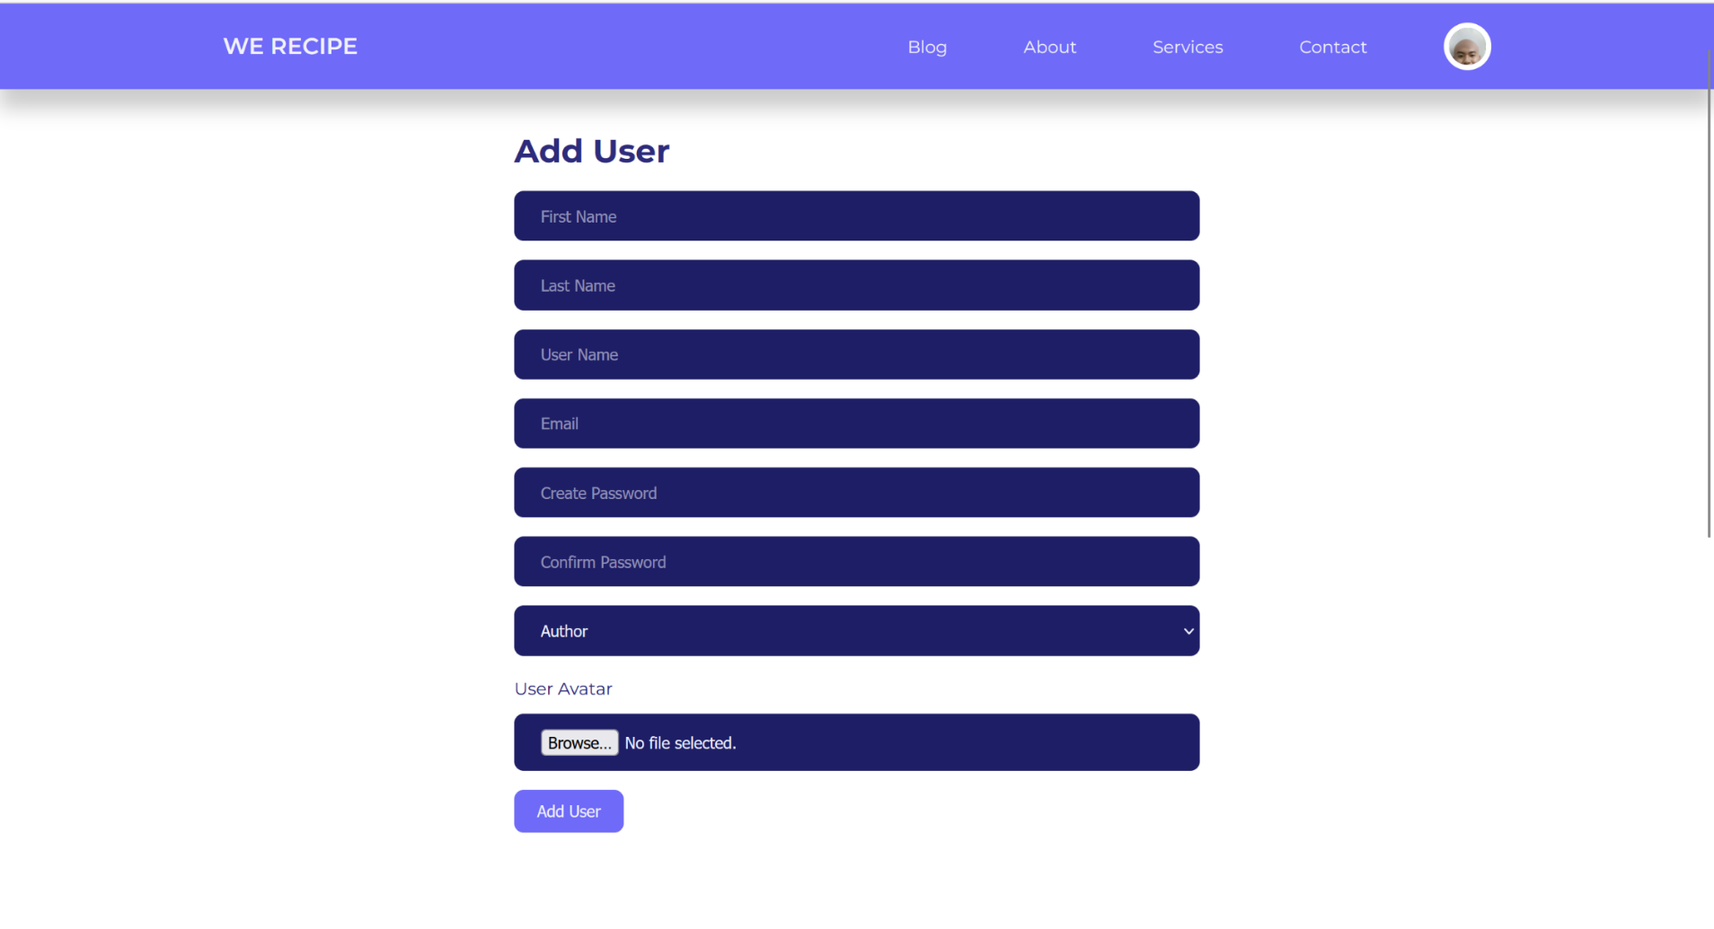

- **Edit and Delete User Information:** Administrators also have the ability to edit or delete user information as needed. The 'Manage Users' interface provides an overview of all users and related management options.

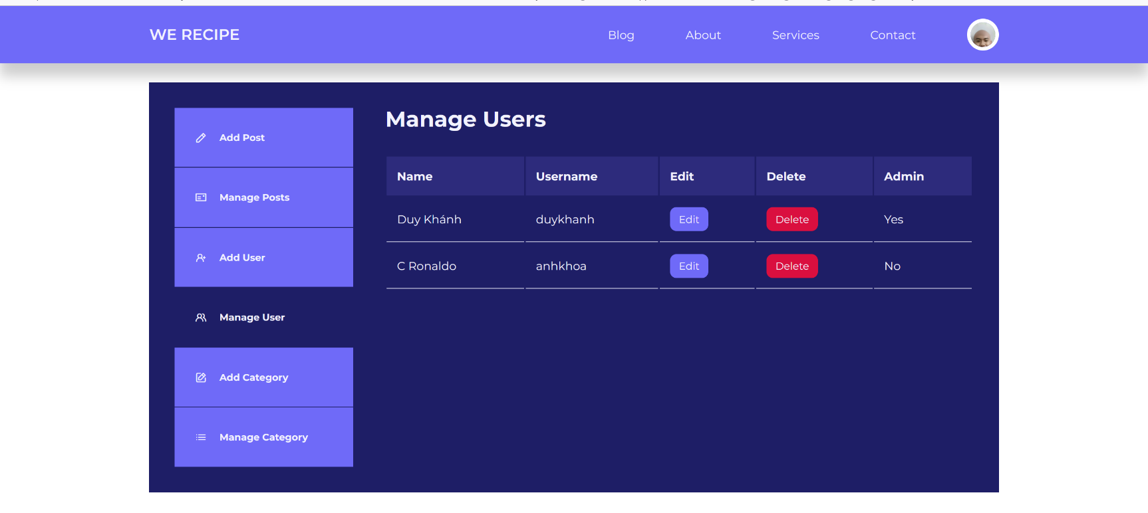

## 2. Recipe Post Management Functions

### a. Overview of Posts:

The website allows users to create posts about cooking recipes, providing comprehensive and engaging information for readers:

* **Recipe Name:** Users enter the name of the dish at the beginning of the post to attract attention.
* **Select Category:** Users choose a suitable category from the available list for easy classification and searching.
* **Description of the Dish:** The description section provides detailed information about the dish, including ingredients, nutritional value, and the history of the dish if available.
* **Step-by-step Instructions:** Each post includes specific step-by-step instructions so that readers can easily follow and prepare the dish.
* **Thumbnail Image:** Users can insert a thumbnail image for the dish to illustrate, making the post more vivid and attractive. Note that images are only accepted in .png or .jpg format to ensure compatibility and display quality.

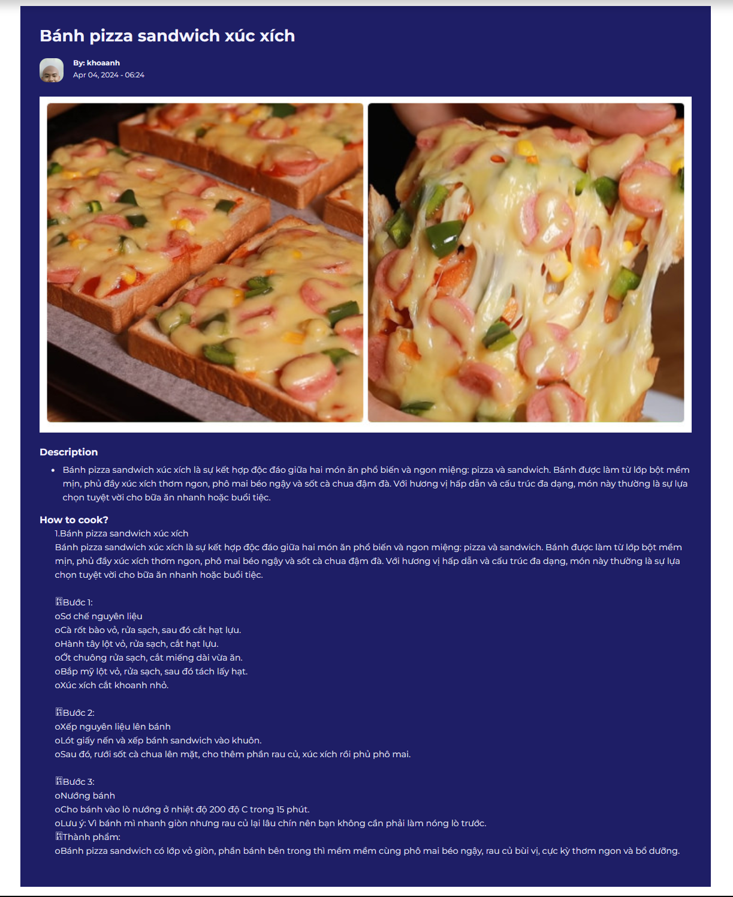

### b. Management of Posts

- **Posting a Recipe:** Users can share their cooking recipes by uploading them to the website. The interface for posting recipes is designed to allow users to easily add, edit, or delete their posts.

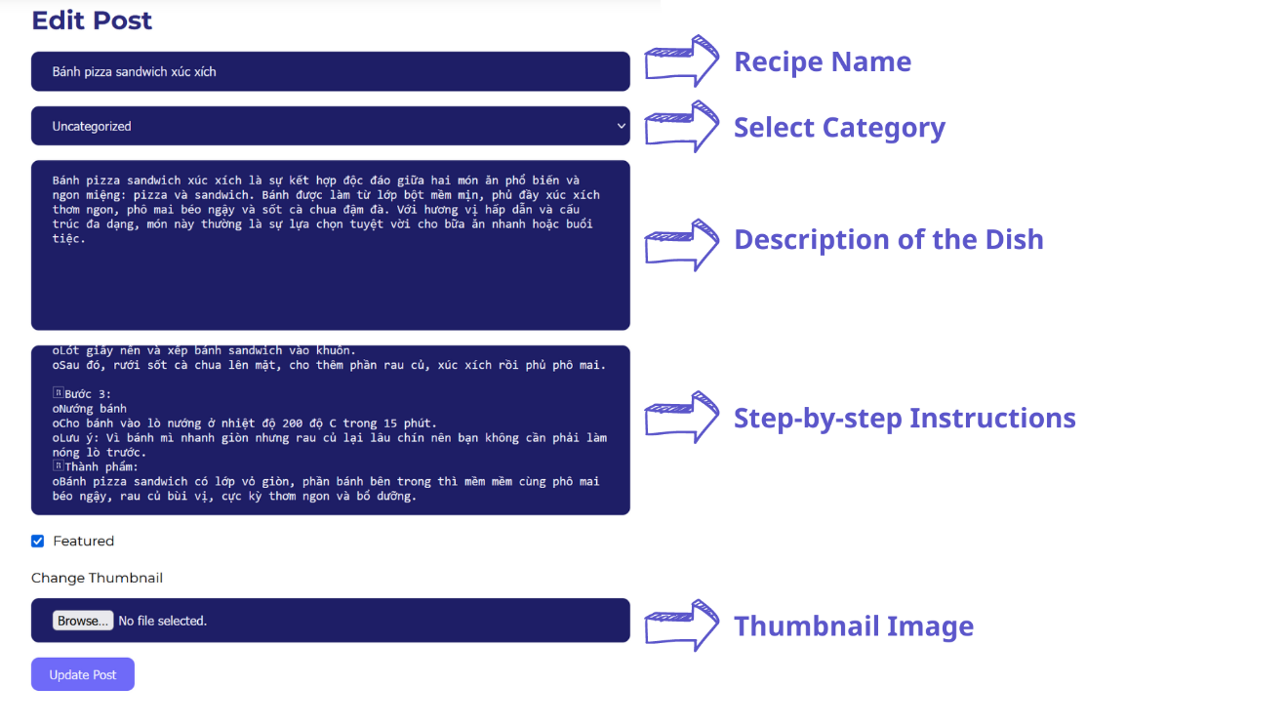

- **Post Management:** For administrators, they have the ability to manage all cooking recipe content posted by users. The manage post interface provides the necessary tools for administrators to easily perform actions such as adding new posts, editing, or deleting posts.

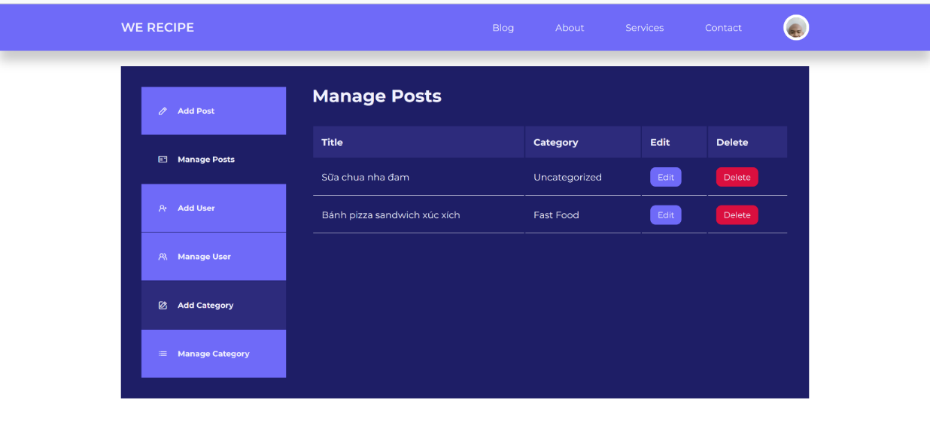

### c. Recipe Post Search

The website provides two methods for searching cooking recipes to optimize user experience:

**Method 1: Search Bar:** Users can utilize the search bar to enter keywords and search for specific cooking recipes. This feature enables quick and accurate searches, delivering instant results tailored to the user's requirements.

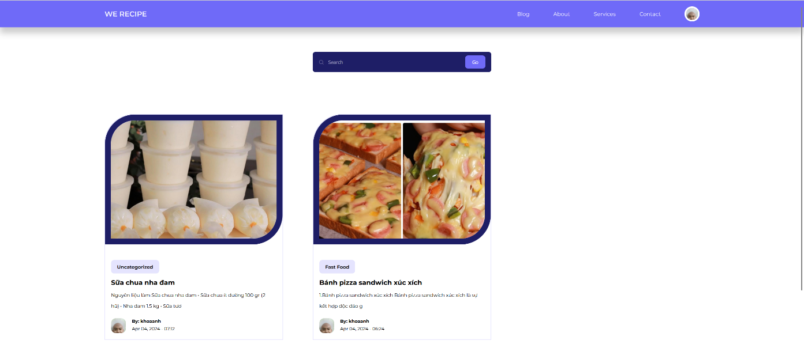

**Method 2: Category Selection:** This feature allows users to filter posts by selected categories. When clicking on a category, the system will display all related cooking recipes, making it easy for users to search based on their preferred topics.

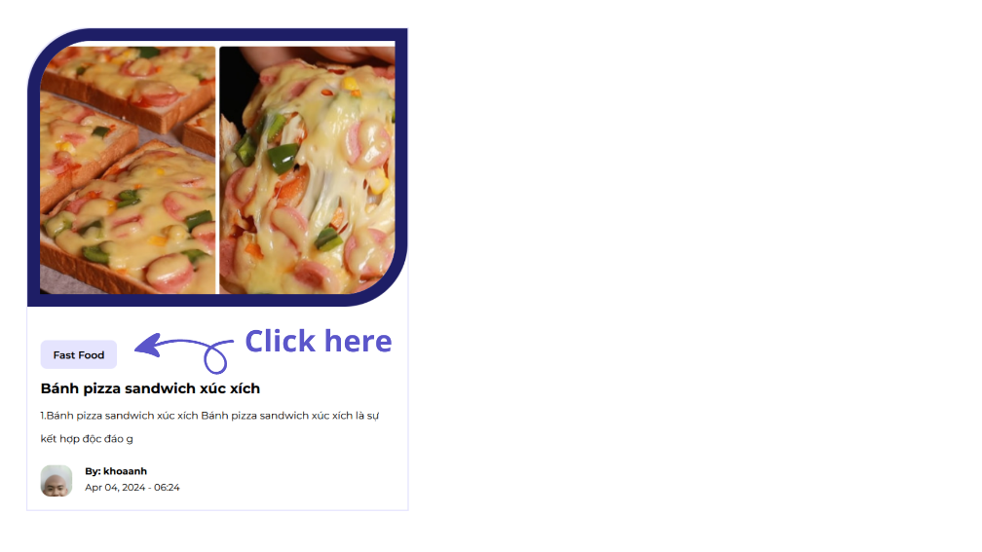

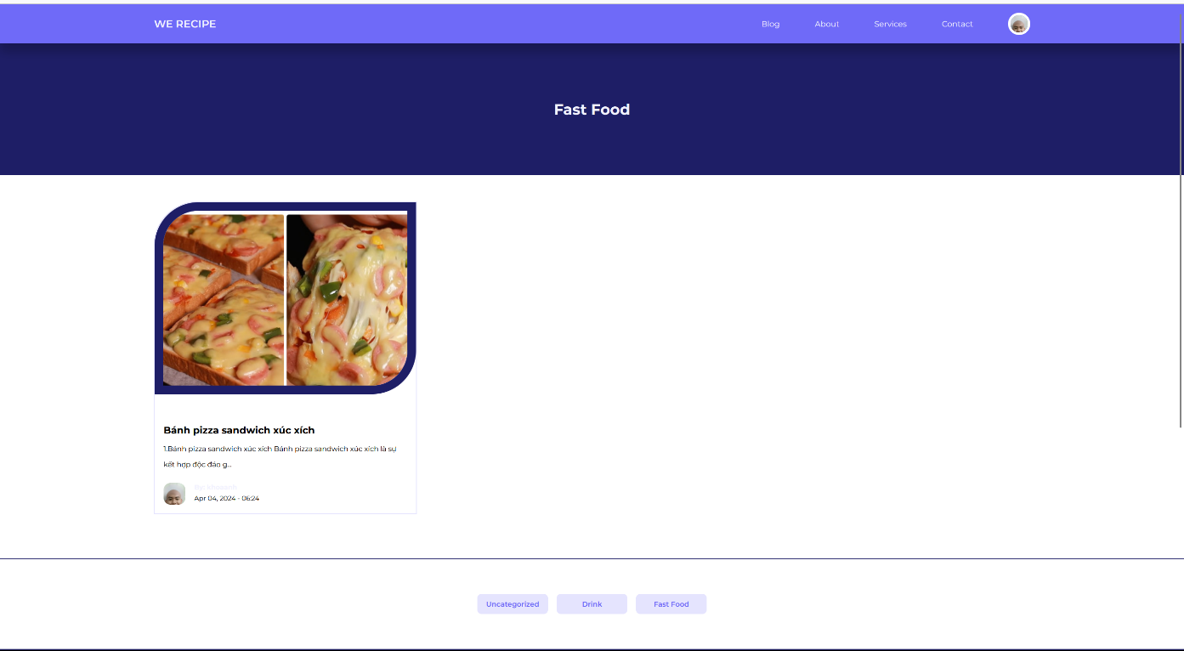

Additionally, users can choose other category topics through the footer bar below to explore more new dishes.

### d. Interactions in Recipe Posts



Our website provides various interactive features, allowing users to express their preferences and engage with the community

* **Like Button:** Users can show their appreciation for a recipe post by liking it, increasing interaction and encouraging the content creator.
* **Comments:** Each recipe post allows users to leave comments, share opinions, or ask questions. Users also have the option to edit or delete their comments to ensure accuracy and relevance.
* **Download Recipe:** For favorite cooking recipes, users can choose to download them for convenient reference and use in the future.

### e. Adding, Deleting, Editing Categories

Our website offers flexibility in managing categories, making it easy for both users and administrators to organize content:

* **Selecting Categories:** Users can choose appropriate categories from the available list to classify their posts, making it easier for others to search and access them.
* **Category Management (For Administrators):** Administrators have the authority to add, edit, or delete categories to ensure that the website's content is logically organized and convenient for users.

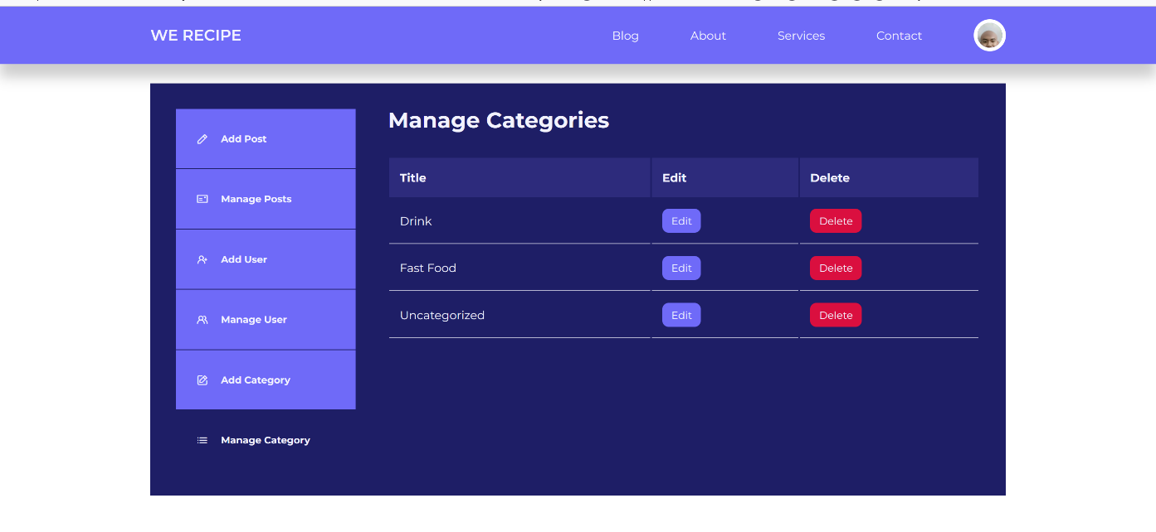

# REFERENCES